🧠 SPLUNK ENTERPRISE SETUP AND LINUX LOG INGESTION

📌 Core Definition
Splunk Enterprise is a Security Information and Event Management (SIEM) platform that:
- Collects logs from systems
- Indexes them into searchable events
- Enables analysts to investigate security activity
In this lab:
- Splunk runs on Ubuntu Server (no GUI)
- Logs are ingested locally (agentless)
- Splunk Web is accessed from Windows browser
Important rule:
If Splunk and logs are on the same host, no agent is required.

🎯 Overall Objective
To install Splunk Enterprise on Ubuntu Server, validate service health, ingest real Linux logs, and confirm data integrity before learning Splunk usage or detections.

🧱 Prerequisites (Must Be True)
Before starting:
- Ubuntu Server installed (no GUI)
- Minimum 4 GB RAM
- Minimum 50 GB disk
- Internet access
- SSH access from Windows
If any prerequisite fails → stop and fix first.

🔹 PHASE 2 — Splunk Enterprise Installation & Validation

STEP 1️⃣ — Download Splunk Enterprise (CLI)

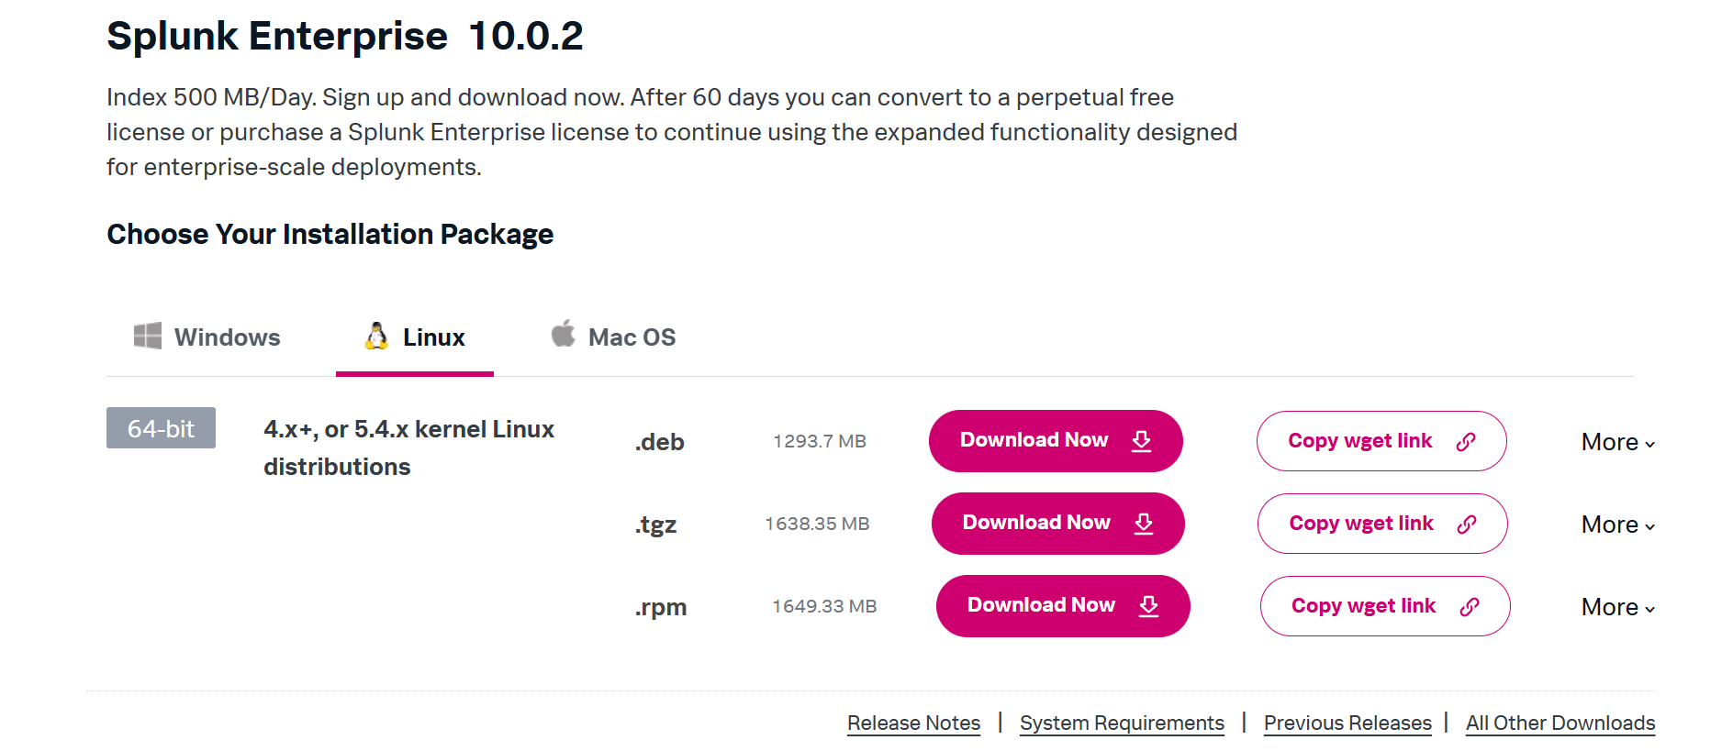

Definition
This step retrieves the Splunk installation package directly onto the server.

Action (Ubuntu via SSH)
cd /opt
Use sudo wget -4 -c --progress=bar URL to force IPv4 downloads, because by default wget may try IPv6 first, which can be slow or fail on some networks. If wget is missing:
sudo apt install wget -y

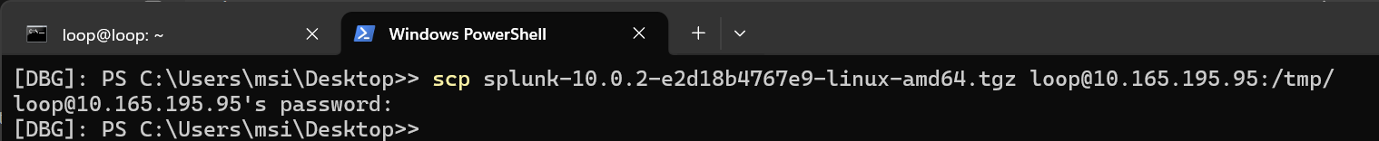

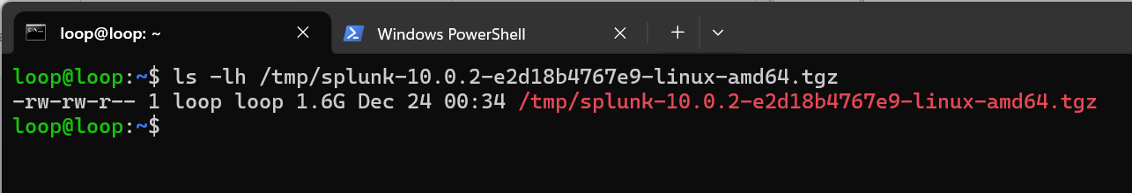

I’m using a different method for installing Splunk, so please proceed with whatever is easiest for you. I downloaded Splunk using FDM on Windows OS, then copied the file with the scp command

STEP 2️⃣ — Extract Splunk Package

Definition
Extraction unpacks Splunk binaries into the filesystem.

Action
sudo tar -xvzf splunk.tgz
Verify:
ls /opt/splunk
Expected directories:
- bin/
- etc/
- var/
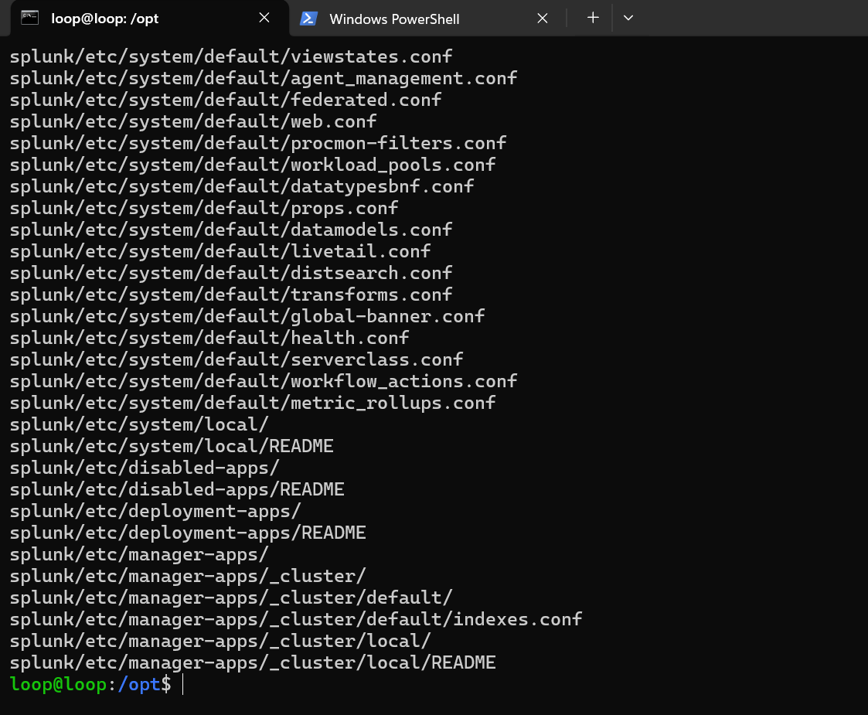

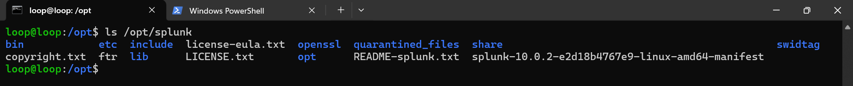

STEP 3️⃣ — Start Splunk for the First Time

Definition
Initial startup initializes Splunk services and creates the admin account.

Action
cd /opt/splunk/bin
sudo ./splunk start

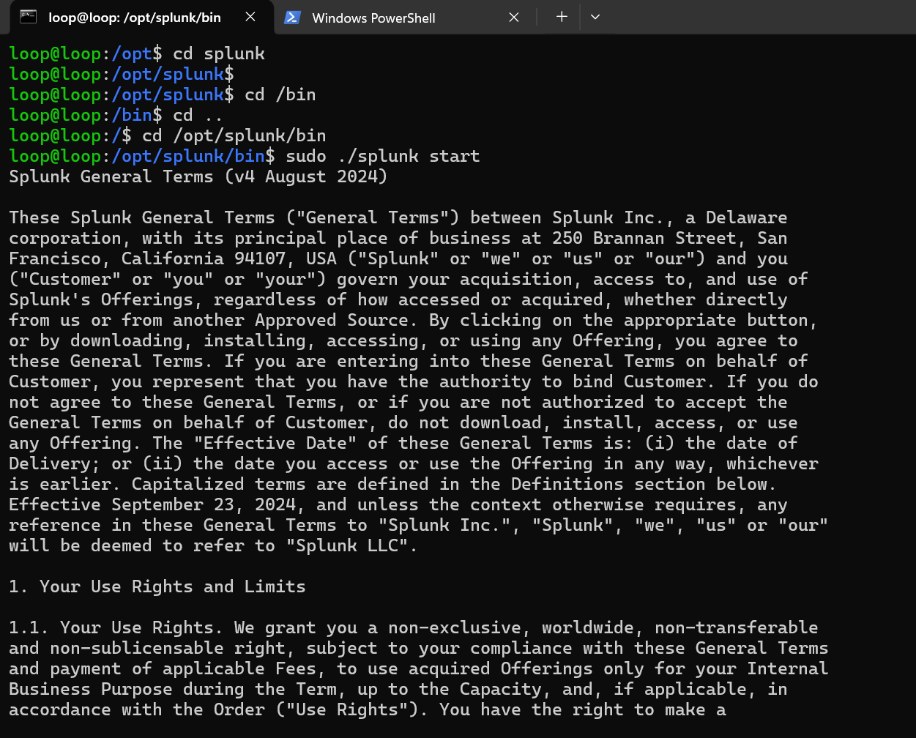
During startup:
- Accept license (yes)
- Set admin username
- Set admin password
📌 Save credentials securely.
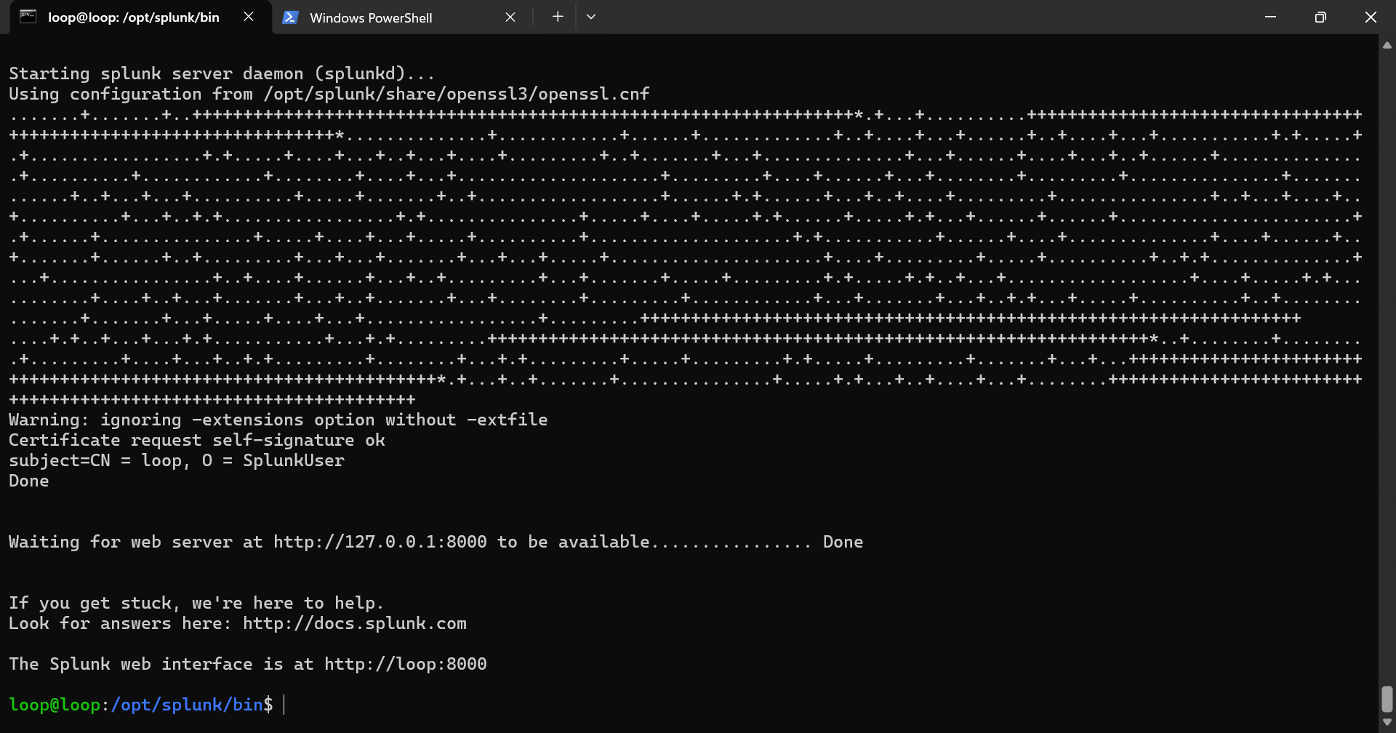

STEP 4️⃣ — Verify Splunk Service Status

Definition
Confirms that the Splunk daemon (splunkd) is running.

Action
./splunk status
Expected:
splunkd is running
If not running → do not continue.
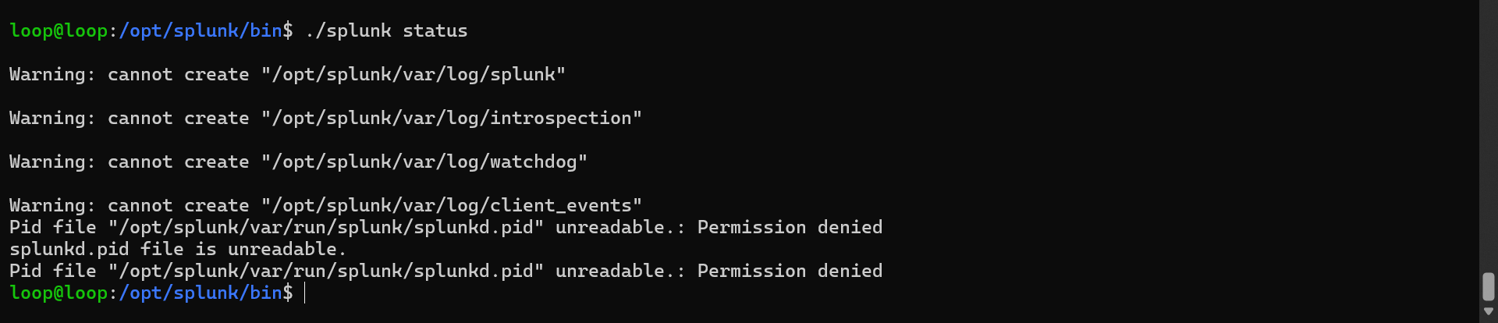
Problem: Splunk cannot write files because it belongs to root, but you are running it as user loop

Wipe broken runtime files (SAFE)
These are temporary files causing the block.
sudo rm -rf /opt/splunk/var/run/splunk sudo rm -rf /opt/splunk/var/log/*

Fix: Change the ownership of the file : sudo chown -R loop:loop splunk
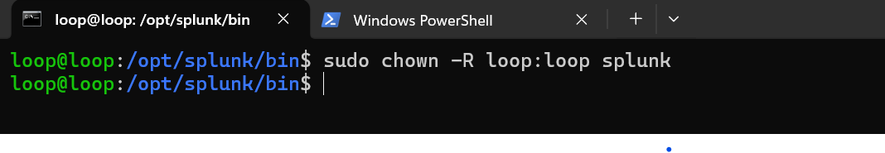

FIXED :
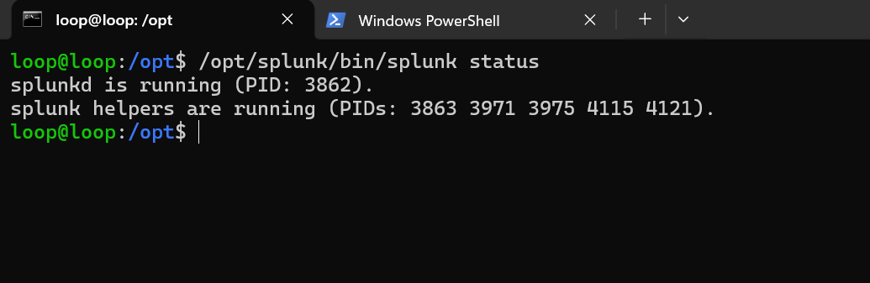

STEP 5️⃣ — Enable Splunk at Boot (Recommended)

Definition
Ensures Splunk starts automatically after reboot.

Action
sudo /opt/splunk/bin/splunk enable boot-start -user loop

STEP 6️⃣ — Allow Splunk Web Port

Definition
Splunk Web uses TCP port 8000.

Action
sudo ufw allow 8000/tcp
sudo ufw reload

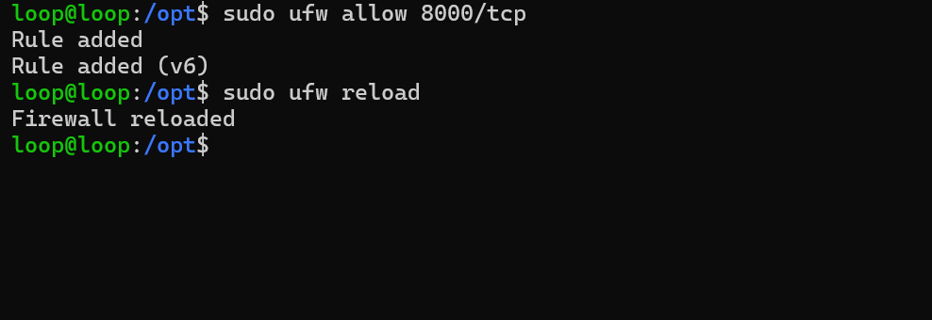

STEP 7️⃣ — Access Splunk Web Interface

Definition
Splunk Web is the analyst-facing interface for searching and investigation.

Action (Windows browser)
http://<UBUNTU_IP>:8000
Login:
- Username: admin
- Password: (set earlier)
⚠️ Do not configure dashboards, alerts, or apps.

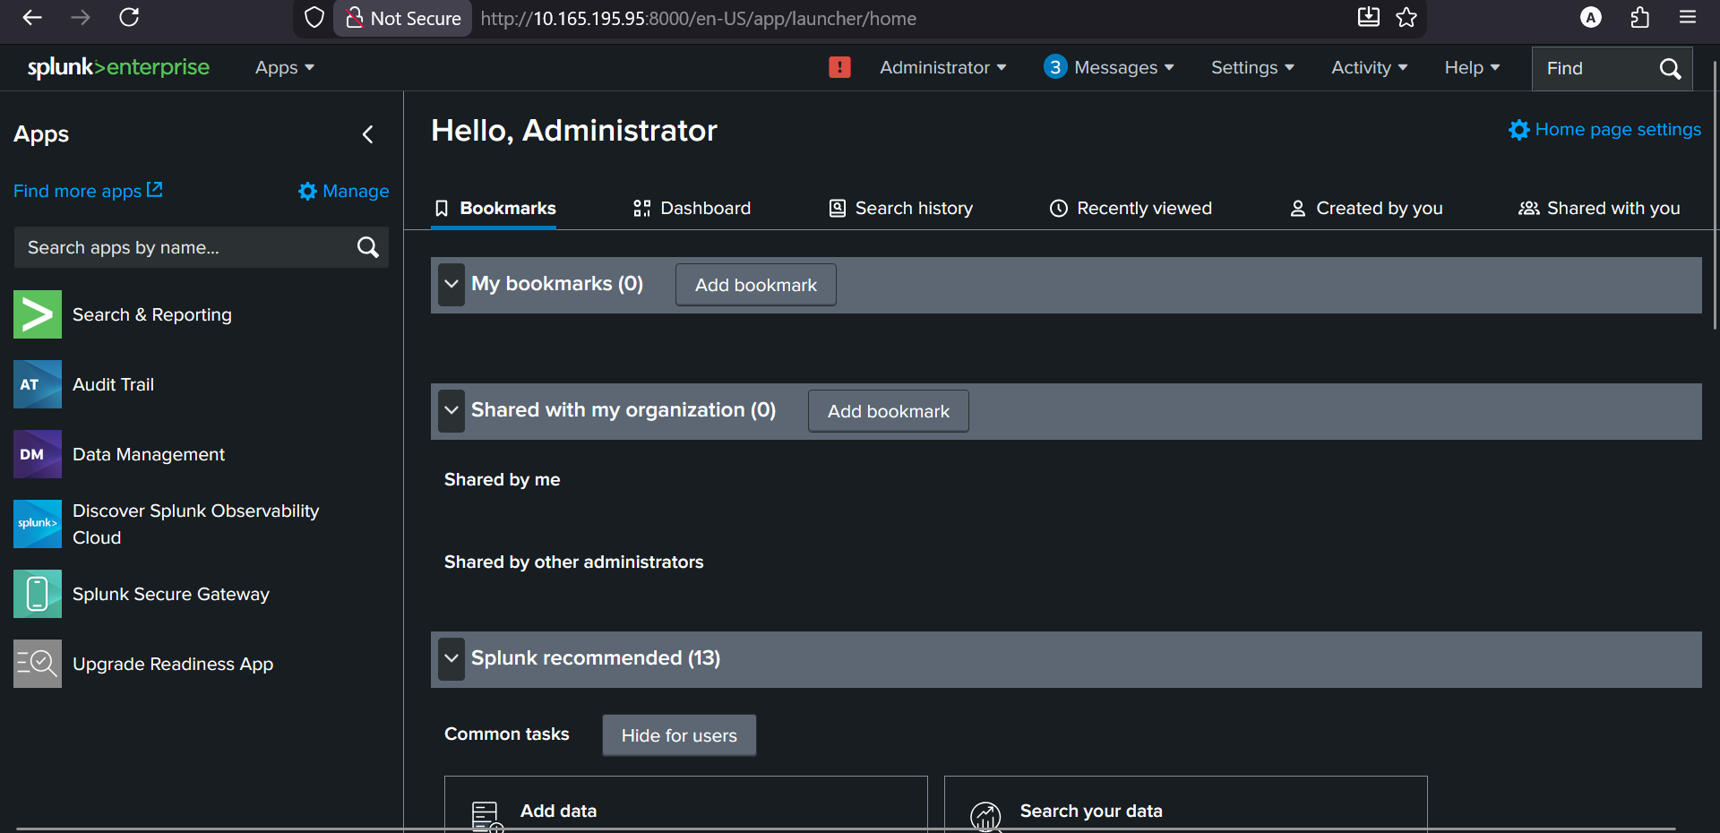

STEP 8️⃣ — Validate System Health (SOC Check)

Definition
Ensures the SIEM has sufficient resources before ingesting logs.

Action
free -h
df -h
Expected:
- ≥ 3 GB RAM available
- ≥ 8 GB disk free

🔹 PHASE 3 — Linux Log Ingestion (Agentless)

📌 Definition
Agentless Linux log ingestion means Splunk directly reads log files located on the same system where Splunk is installed.
No Splunk Forwarder is required in this phase.

🎯 Objective
To ingest Linux authentication and system logs and validate them as trustworthy SOC telemetry.

STEP 9️⃣ — Define Log Scope

Logs Selected
Log File | Purpose
/var/log/auth.log | SSH, sudo, authentication
/var/log/syslog | Cron, services, system activity
❌ Not ingesting:
- Apache logs
- Debug logs
- Sample data
- Apps
SOC rule:
Ingest behavior evidence only.

STEP 🔟 — Create a Dedicated Index

Definition
An index separates data logically for clean investigation.

Action (Splunk Web)
- Go to Settings → Indexes
- Click New Index
- Name: linux
- Save
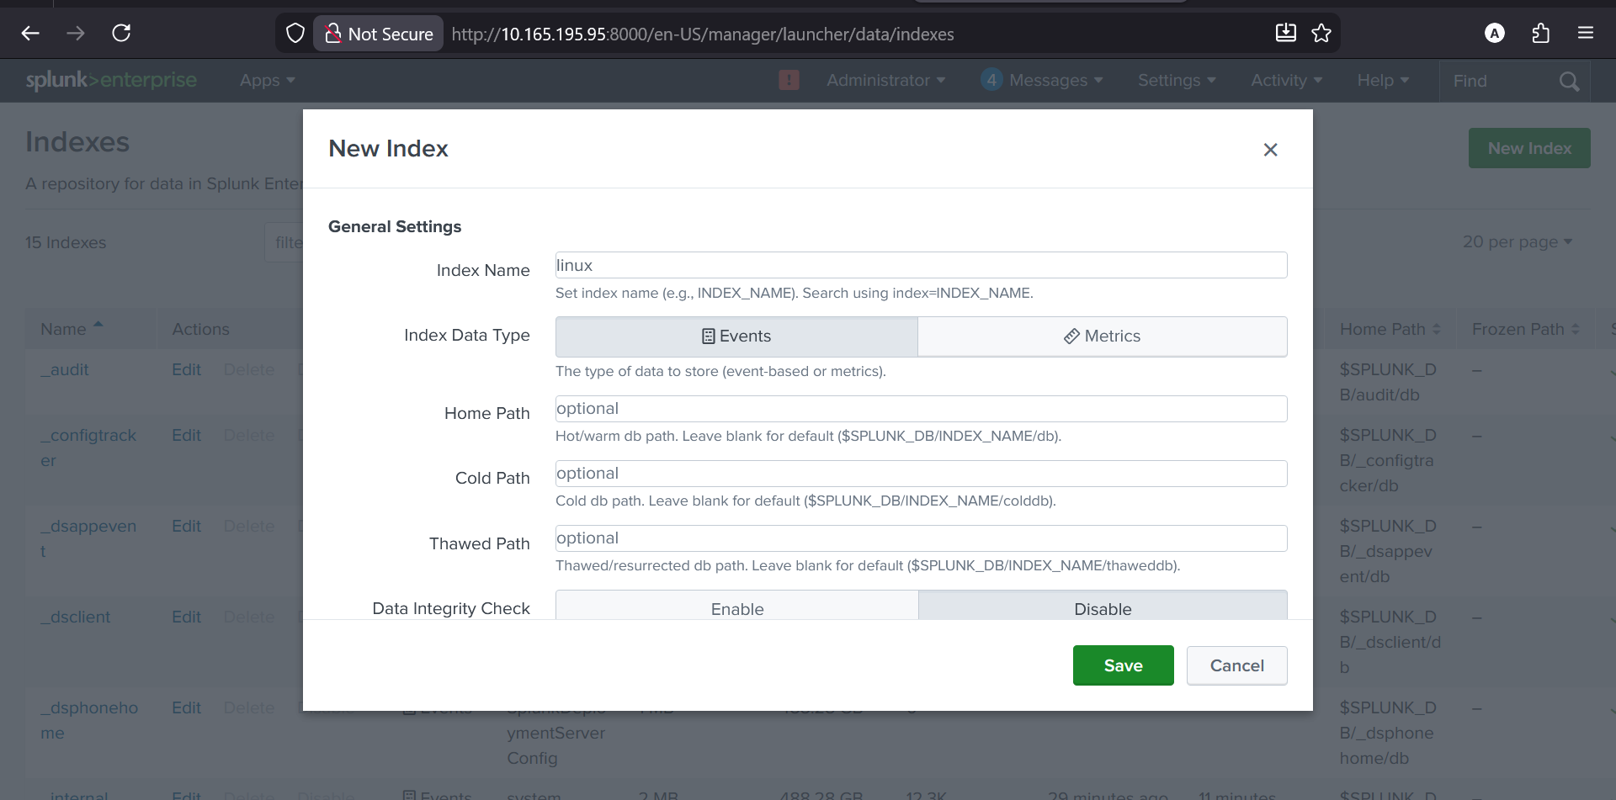

STEP 1️⃣1️⃣ — Configure File Monitoring

Definition
File monitoring tells Splunk which local files to watch continuously.

A. Add /var/log/auth.log

1️⃣ Open File Monitoring
- Go to Settings → Data Inputs
- Click Files & Directories
- Click New Local File & Directory

2️⃣ Path
In File or Directory:
/var/log/auth.log
Click Next
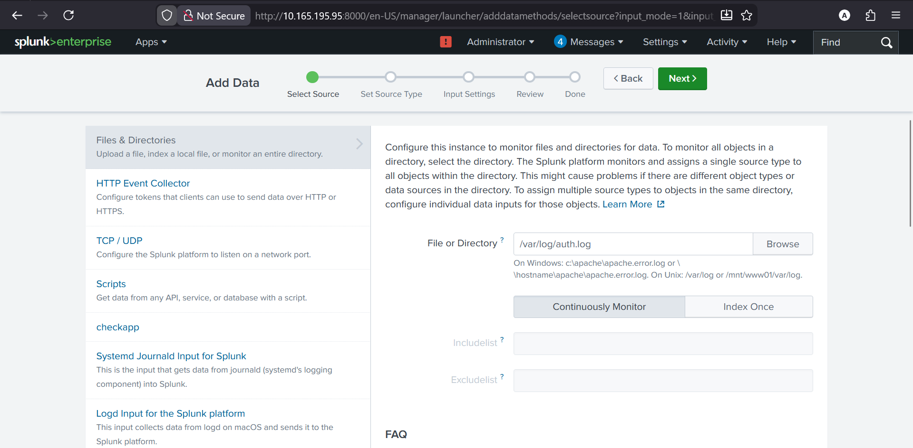

3️⃣ Source type
Choose:
linux_secure
(If not available, choose syslog)
Click Next
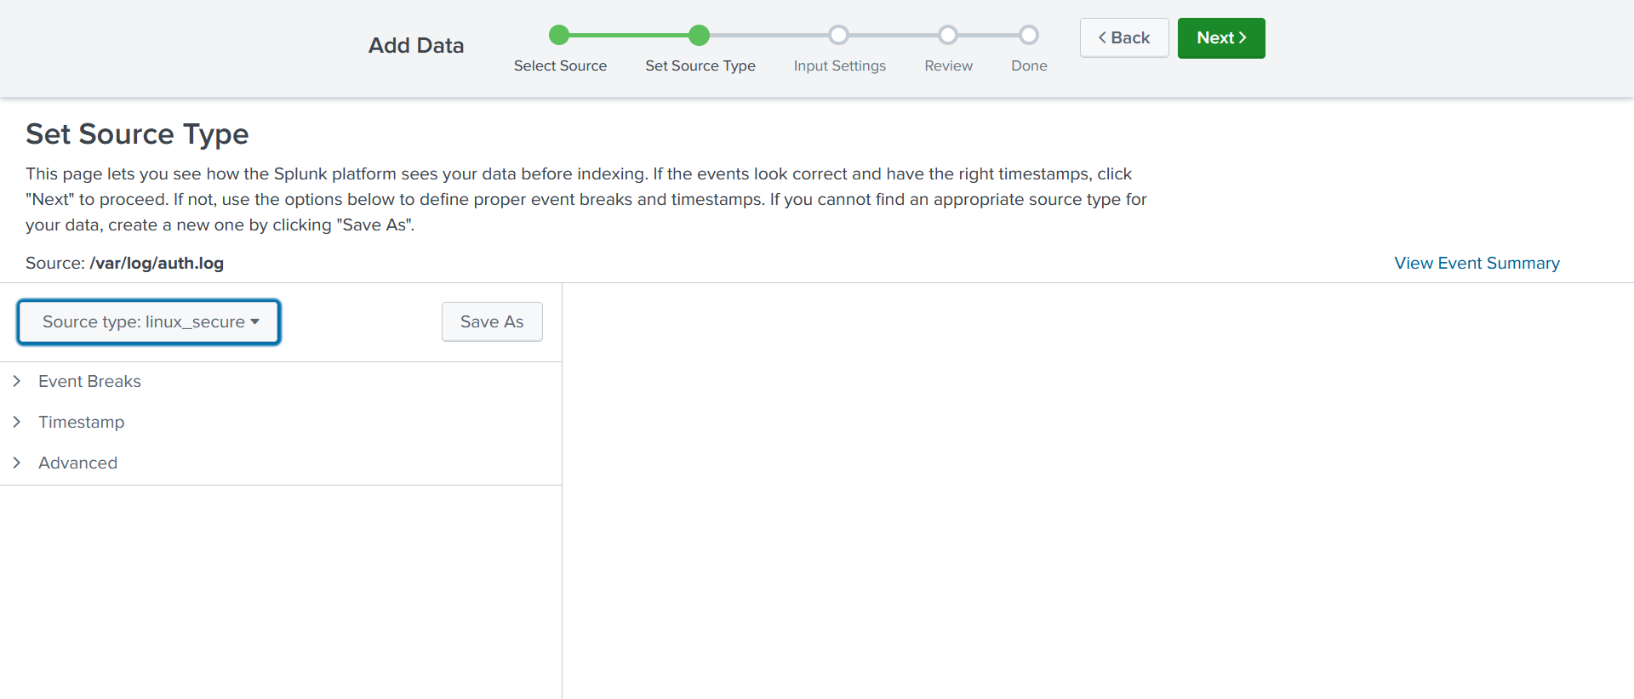

4️⃣ Index
- Select Index
- Choose:
linux
Click Review → Submit

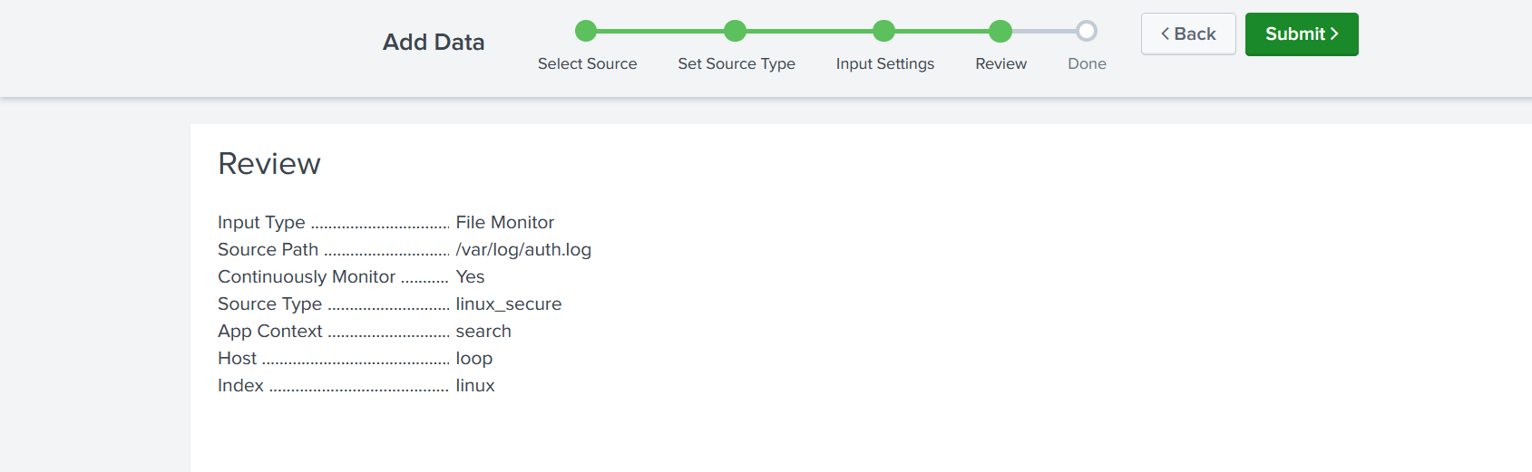

B️. Add /var/log/syslog
Repeat the same process.

1️⃣ Path
/var/log/syslog

2️⃣ Source type
Choose:
syslog

3️⃣ Index
linux
Submit.

That’s it. Configuration is DONE.

STEP 1️⃣2️⃣ — Verify Ingestion

Action (Search & Reporting)
index=linux
You must see events.
If not → stop and troubleshoot.

STEP 1️⃣3️⃣ — Validate Each Log Source (SOC Method)
index=linux source="/var/log/auth.log"
index=linux source="/var/log/syslog"
Confirm presence of:
- sshd
- sudo
- cron
- systemd

STEP 1️⃣4️⃣ — Generate a Controlled Test Event

Action (Ubuntu)
sudo su
exit

Verify in Splunk
index=linux sudo
A new event must appear.

STEP 1️⃣5️⃣ — Time Synchronization Check
- Set time range to Last 15 minutes
- Confirm timestamps match system time
Incorrect time = broken investigations.

❌ What Is Intentionally Not Done Yet
- No alerts
- No dashboards
- No SPL learning
- No Windows logs
- No apps
Current SOC question:
“Can I trust this data?”

✅ Final Success Checklist
✔ Splunk installed
✔ Splunk running
✔ Web UI accessible
✔ Linux logs ingested
✔ Test event visible
✔ Time accurate
If all true → SIEM is operational.

